**Oasis Centre New 'Hub' for North East**

Jane Boehr  
Nipawin Journal  
Wednesday, June 24, 2015 3:27:57 MDT PM   
<http://www.nipawinjournal.com/2015/06/24/oasis-centre-new-hub-for-north-east>

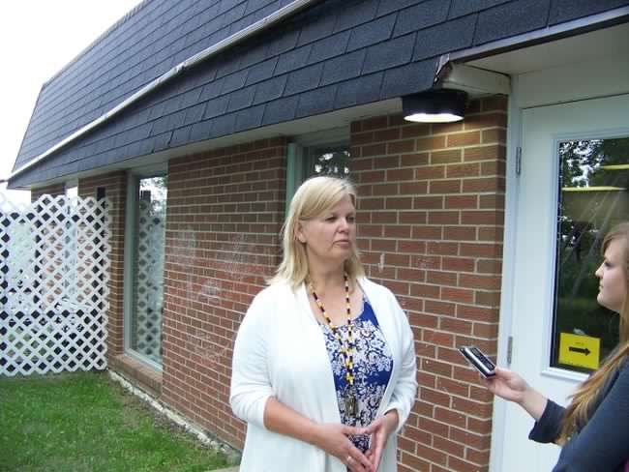

The Executive Director of the Oasis Centre, Joy Hanson, can happily boast about the recent outcomes of the 2015 Annual General Meeting on June 23. The Centre has recently received additional funding from the Federal Government that will bring the once struggling organization out of the red and into the black. Hanson says there is an energy that’s coming from the community now wanting to give back. All the effort and time that’s gone into making the Oasis Centre a thriving ‘safe house’ for many has come full circle. Hanson recalls the times when things were tough.

“It was a lot of work, a few years ago we were struggling financially, so [with] the funders coming on, the [increase in] participants, we were able to get through that rough point. [Now] people are seeing what we do here and are wanting to be a part of it, making a difference. People are getting it”.

Hanson was visibly moved as she spoke about the positive changes she's seeing at the facility. She says being able to get to this point during her tenure has meant so much for so many.

“We are becoming more financially stable every year, we have some reserves now”.

Hanson says the family support program at Oasis received funds through Social Services.

“Going from a $85,000 to a $288,000 grant is very significant for the centre, [this is] allowing us to expand our family support program. [We are] covering the North East, and are becoming more the hub”.

Hanson is encouraged with the dramatic increase in funding. The amazing part about the growth and the much needed funding coming through is that it’s been a bottom up or grassroots type of growth. The centre has also seen an increase in partnerships with Red Earth, the Prince Albert Grand Council which covers 12 reserves in Northern Saskatchewan, and continued growth in the pillar programs at Oasis in youth programming and the mental health programming.

“We’re up to 12 or 13 staff members, and we have a lot of cultural leaders who provide additional support. [The funding has] really increased what we are able to do because the more staff, the more programs, and the more people you help”.

Hanson says they used some of their capital funds to do maintenance to the facility.

“The capital funding has helped save the building which was becoming dilapidated. So, being able to fix the roof, and [have] safe transportation, those all make a huge difference. With the extra staff in the family support program and with the new funding from social services that’s helped us be able to help a lot of families stay together. [Which means] less children are in care away from their community and culture.”

Hanson says she first started volunteering at Oasis 5 years ago. She originates from an affluent Southern community and was struck by the abject poverty in Nipawin. She also noticed racism was a real problem in Nipawin when she first started working with young people at Oasis.

“Every time we took the kids out it seemed there was some blatant racism towards them”.

 But Hanson says much has changed over the years.

“Now I can pleasantly say I haven’t seen any acts of racism for 2-3 years now. I can see the difference that our programming makes for social and cultural inclusion in the community. I feel that Nipawin could be a leader in the province to show how a community works together with its neighbours. A healthy, safe community, that’s what our vision was.”

The overall outcome of the AGM was positive. Hanson says they would not be where they are without all the help and support from the community and its sponsors.

“I would just like to thank everyone for all their help, and the elders and cultural leaders for guidance they provided to us. I really see the community working together.